Virtual Event Set Up For All Portfolios

Pre-Event Set Up
- Confirm with your presenter the title and description, date and time for the presentation.
- Determine the credit points (based on presentation time and session objectives) if it is strategic, leadership, or technical domain (ie Leadership 1.0). Submit the PDU request form to secretary@pmi-portland.org
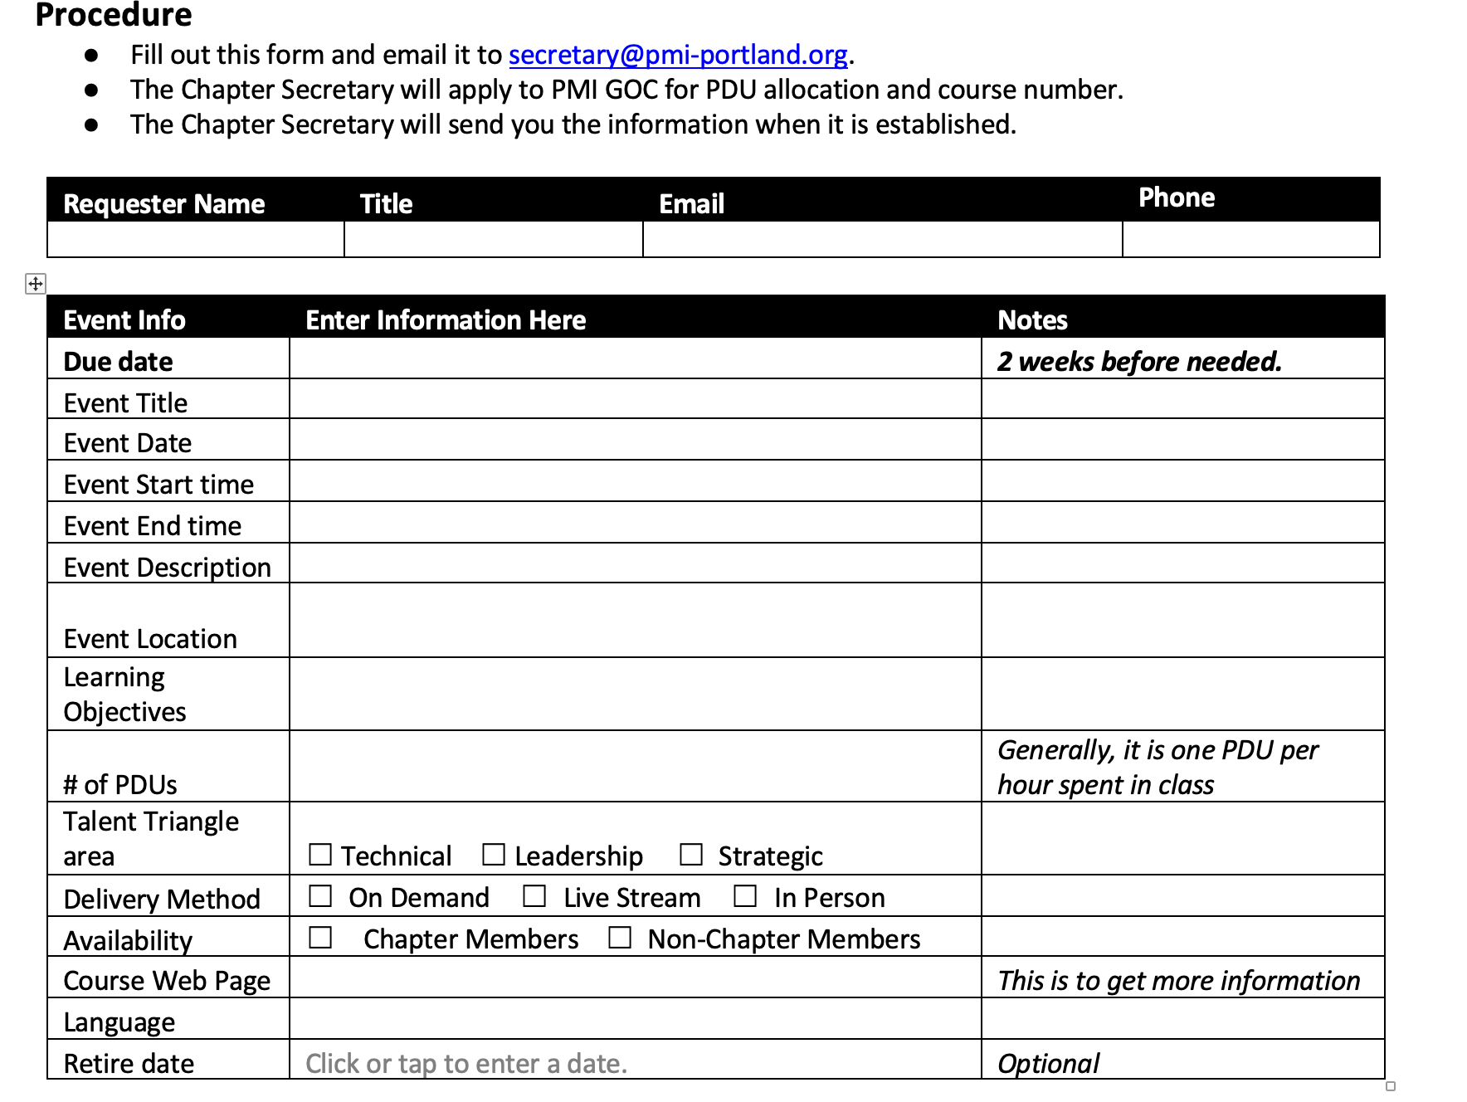
- Follow the steps for submitting the graphics and session info to marketing and setting up the reg request. Log into your PMI Portland Chapter site then go to Board and select Managing Events
  - Note that all sessions are events and follow under the same steps.

- Next step: You will need to set up the zoom meeting link before your send the title, description, photo and bio to marketing for their edits.
  - All PMI Portfolios use the same zoom account:
  - Zoom.us
  - pastpresident@pmi-portland.org
  - Welcome$2020

- Select Schedule Meeting

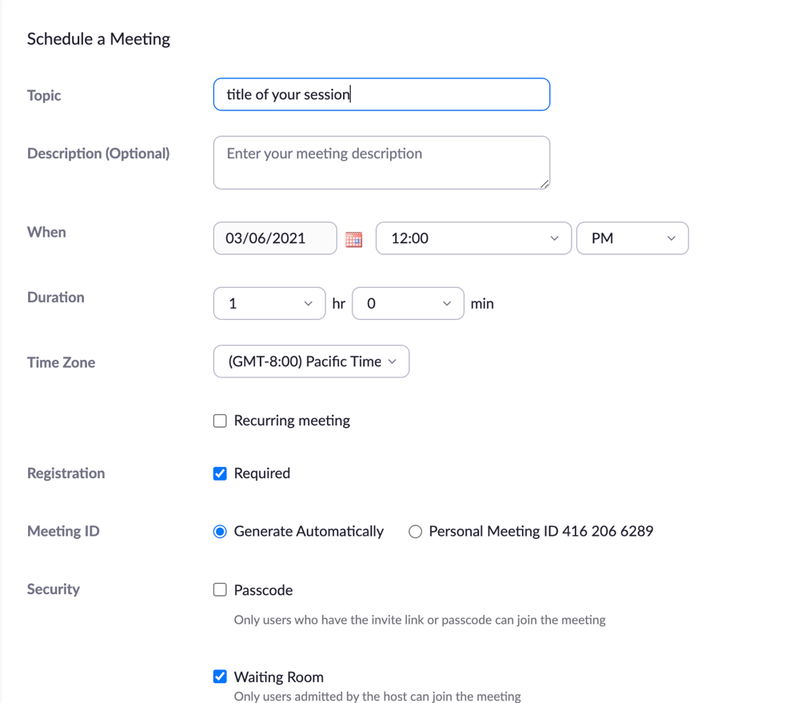

- Add in the title of the session, skip the description, add in the event date.
- Add in the time (including the sound check time) for example I would set it up 12-1pm here 12-12:30pm speaker sound check, 12:30-1pm session. This ensures that no one else will have an event overlapping with your session (since it is a shared zoom account)
- Select registration required so the system captures the names of your attendees so you can pull the reports and know who attended (they will still need to register through our event reg system before they log into zoom)
- Select waiting room so that when you log into the session for your speaker sound check you will then allow the speaker in so your participants don’t hop in unexpectedly and also cyber security reasons.
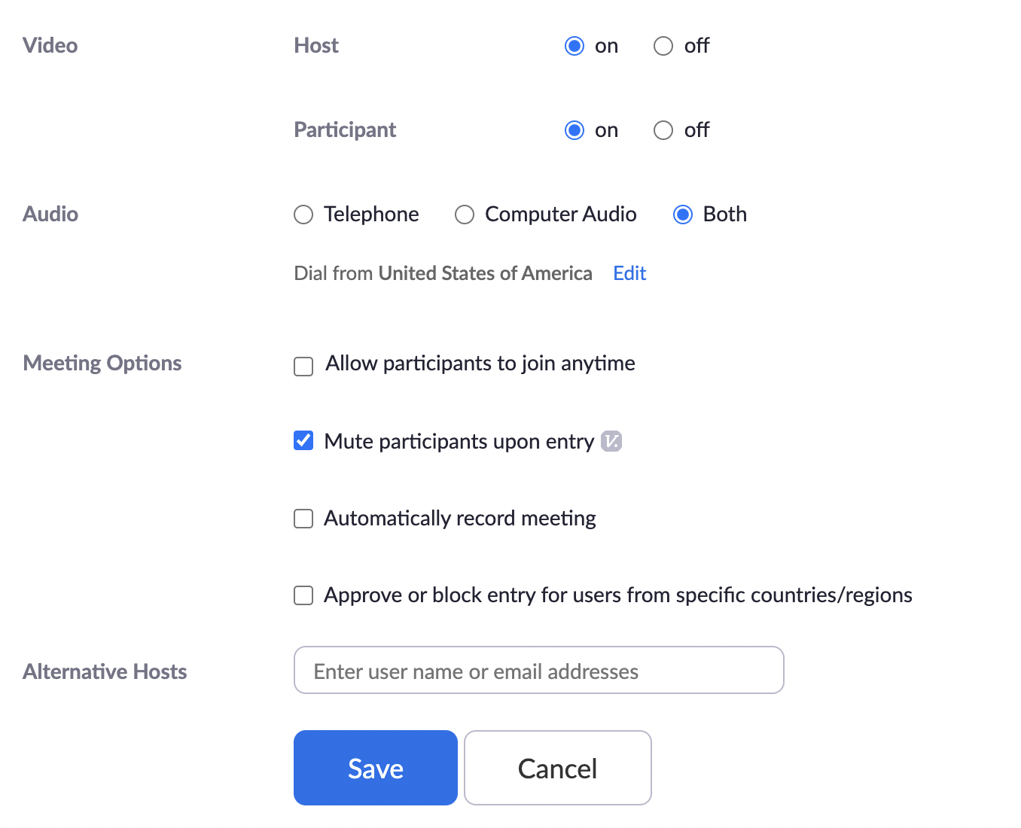
- In the example above both participant and host will have video cams on. This is important if you are using breakout session rooms (recommended) for engagement purposes during your sessions.
  - If you want more of a webinar feel select video on host and no video on participants.
- Select mute participants upon entry so you don’t have participants interrupting your speaker.
- Don’t select auto record your session – you’ll do that during the event. If you select auto record it will start recording when you enter the room which isn’t necessary until you’re ready to present.
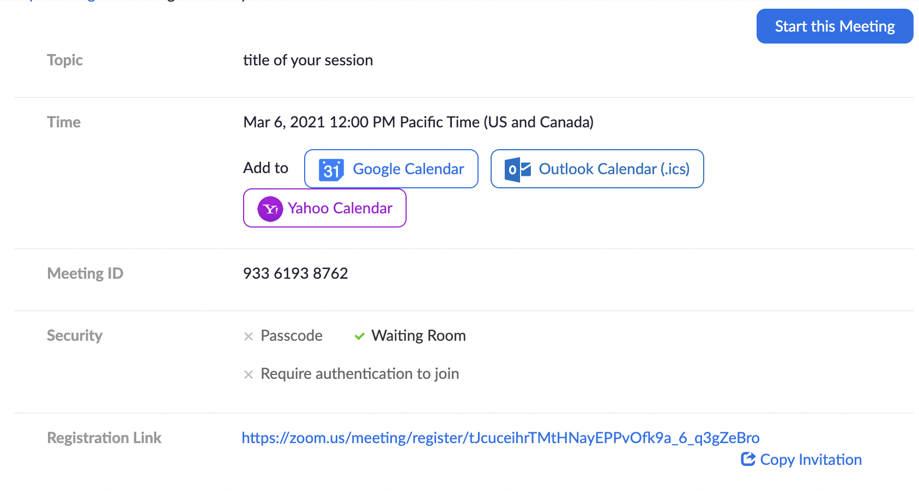
- Next step is to copy the reg link and send that to the VP of marketing and Web Admin for when they set up the registration site and website they will include that zoom link in the email confirmation and reminder emails that go out from the site so you don’t have to send any additional reminders.
- Copy the entire invitation into your PMI calendar and send it out to your PMI portfolio event team and your speaker. Add in the time expectations for when the team hops on the call and when the speaker hops on and when the presentation will be.
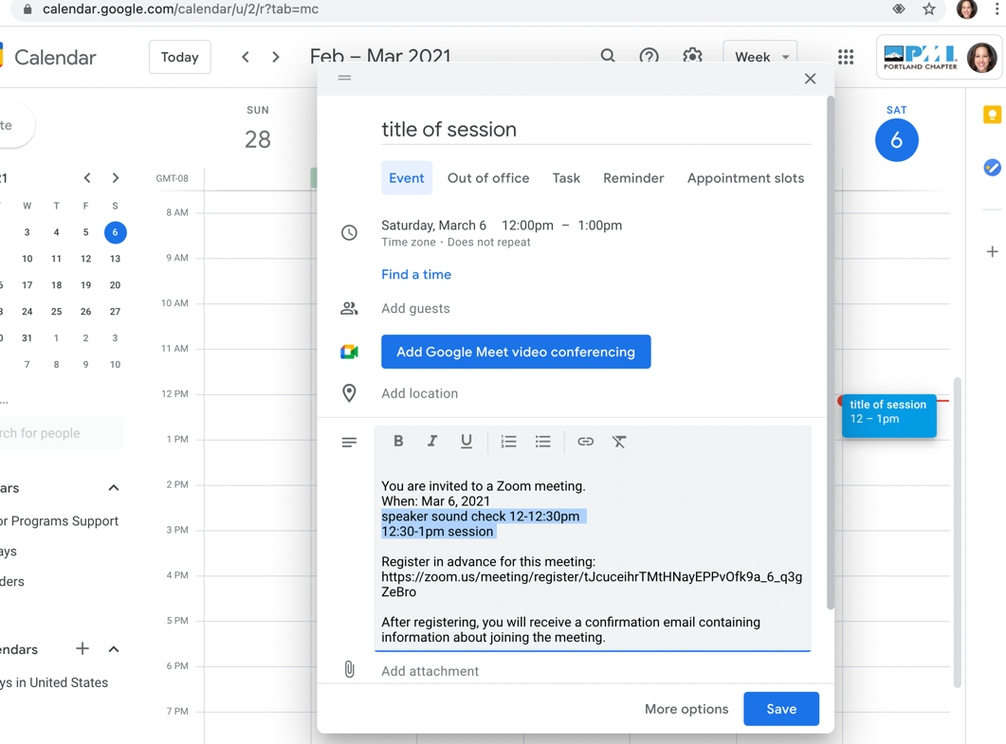
Next step – back on the zoom set up page at the bottom add select poll then add to add in questions that you want to use in order of how you want them to be used (1st poll will be used 1st ect).
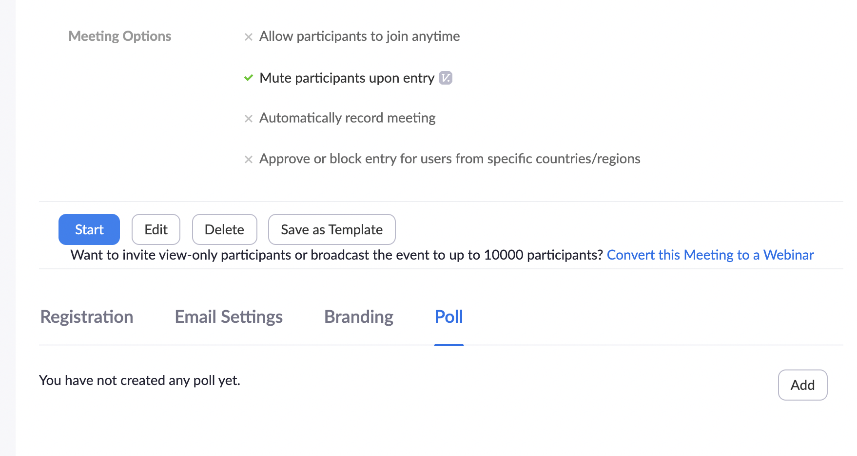
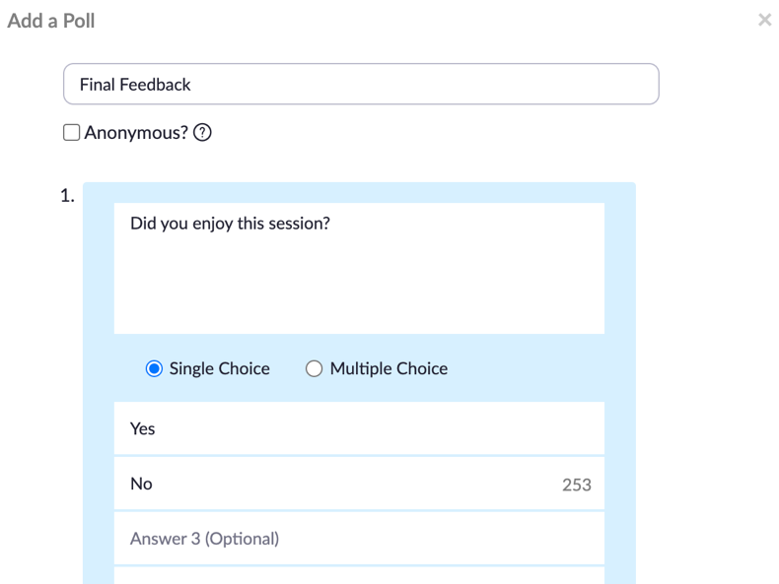
- Note you won’t have the option to use open ended questions – you must add in the question and answer options. The participants can select one or multiple answers.

Event Day
- Login and select start to the right of the meeting title before your sound check is supposed to begin with your team or speaker. The purpose of the sound check is to ensure everything works well audio, video, virtual backdrops, play any videos in their presentation and ensure they check allow audio when sharing their screen.
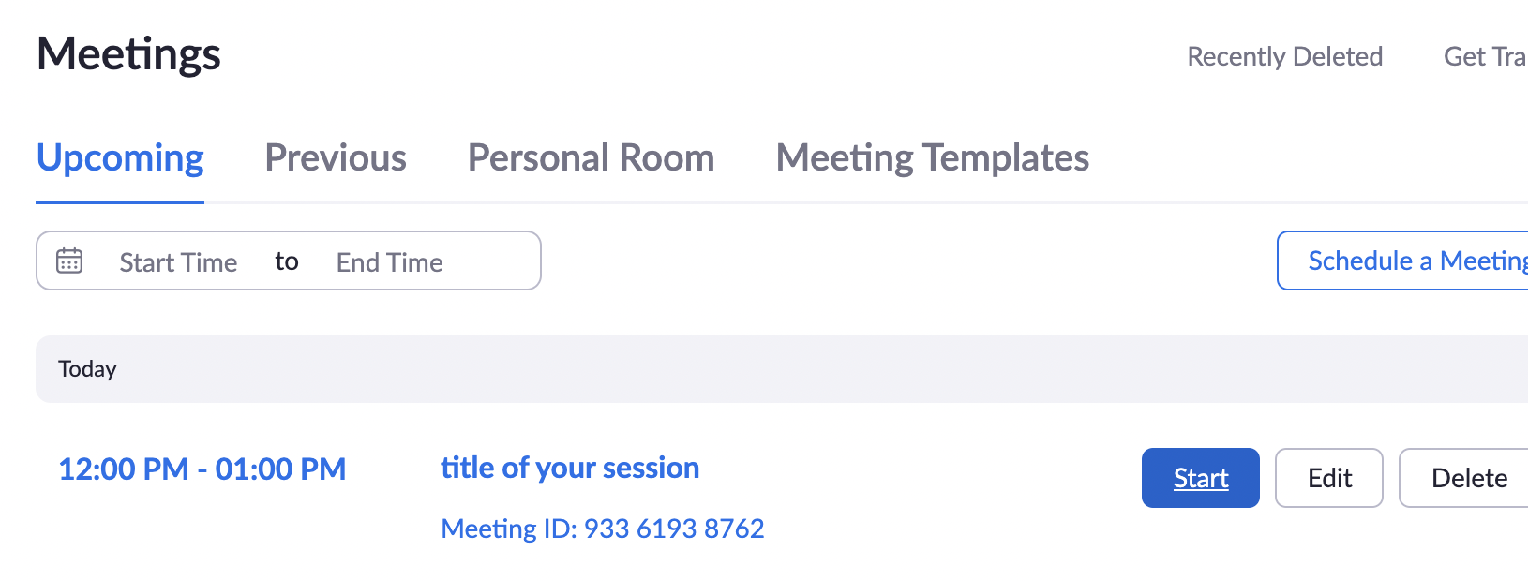
Once you have started the meeting you will need to allow in each of your team members and speakers as they login via the participants tab and select make co-host so they can help share their screens during the presentation. Keep the participants in the waiting room until the start of the presentation time.
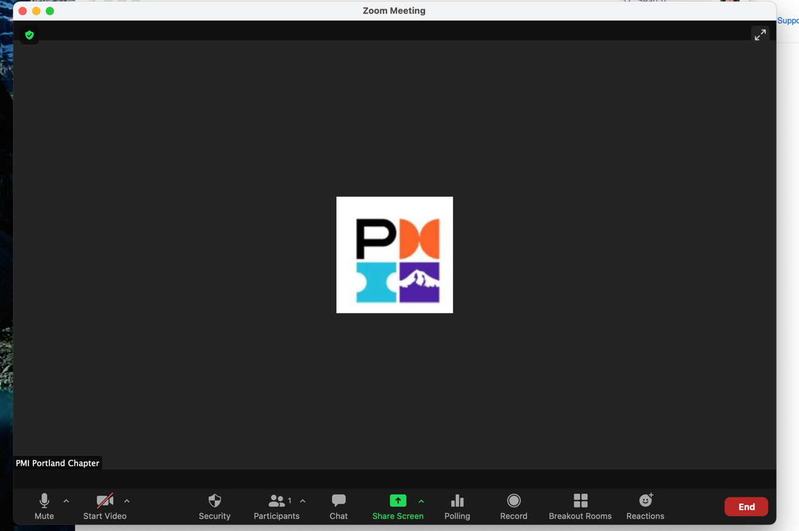
- At the start of the presentation select the record button and select record to the icloud. From there welcome your participants in and have a great session.
- It is recommended to add the session slides into the chat box so participants can download and follow along so make sure you have authorization from the presenter and their final ppt copy.
- During the session you can launch the poll that you preset up by selecting poll then launch the participants will see the results at the same time as you and the participants. Once you are done with the poll just select end poll.
- Always engage your participants in the chat box throughout the session.
- If you want to use the breakout session room option for engagement only the host can set it up (co-hosts won’t have that option). As the host you will be the one that says in the “general session room” while the co-hosts, presenters and participants get asked if they want to join the breakout session rooms. Or when you are setting it up you can label each room so people can opt in to the rooms of their choosing. You can use up to 50 breakout session rooms for the small group discussions. 6 people per room is recommended for small group discussions 1 on 1 sessions are best when you want in depth discussions, mentoring or practicing what they just learned. 5 minutes before you want to bring everyone back together post a message in the breakout room chat. The at the end of the breakout room chat time select end breakout room, it will give 1 min for participants to come back into the “general session room”.
- During the Q&A session at the end of the session add in the participant feedback survey in the chat. Remind participants that they will need to fill it out and the PDU code will be listed at the bottom so they can self-report to PMI global for their attendance.
- Say thank you to the presenter and for everyone participating and then select end meeting.
  - Note the platform won’t give you another speakers only room, everyone will see a message that says this meeting has ended.
After the event
- Run the attendance report to pull the emails for who attended the session. Log into the zoom account then on the left hand side under admin select reports then select meeting add in event date
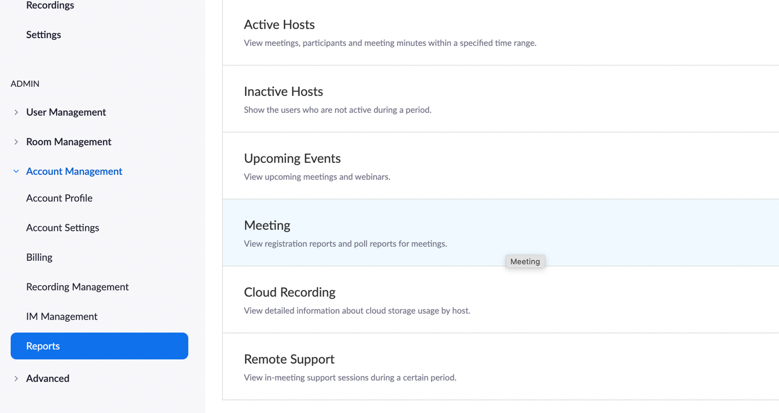
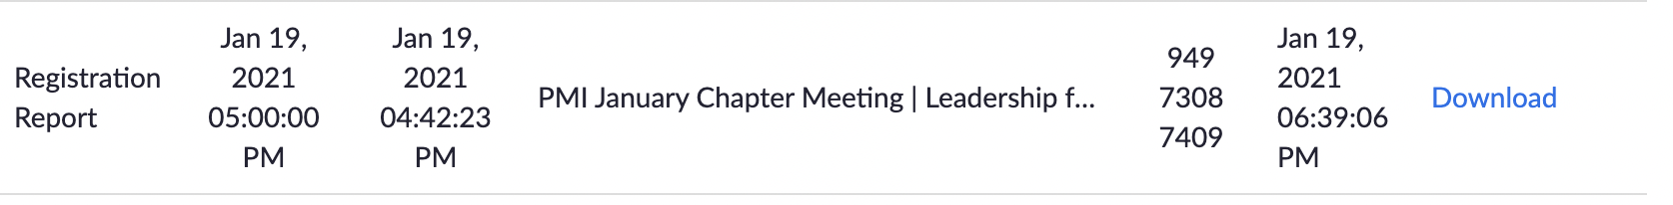
- Select download and save the attendance list in your PMI team folder for future reference.
- Copy the emails from the attendance list and send an email with their emails bcc: to thank them for attending and add in the same google doc link to the presenter feedback form that you put in the chat box during the session for participants.

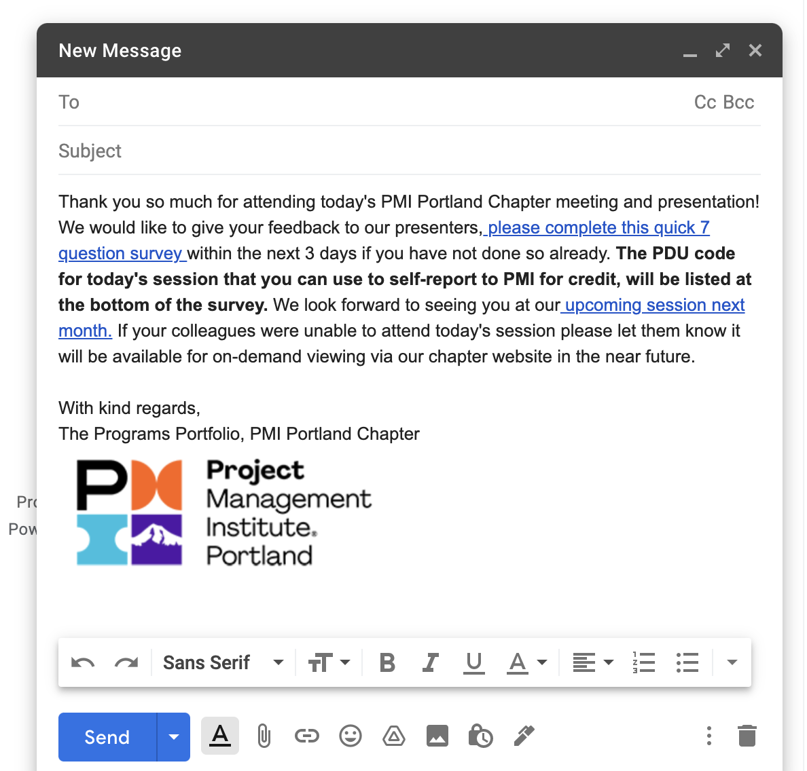
- Next download the mp4 file and send it to the Web Admin to add to the on-demand page on the chapter website. Go to the left column of the zoom page and select recordings:
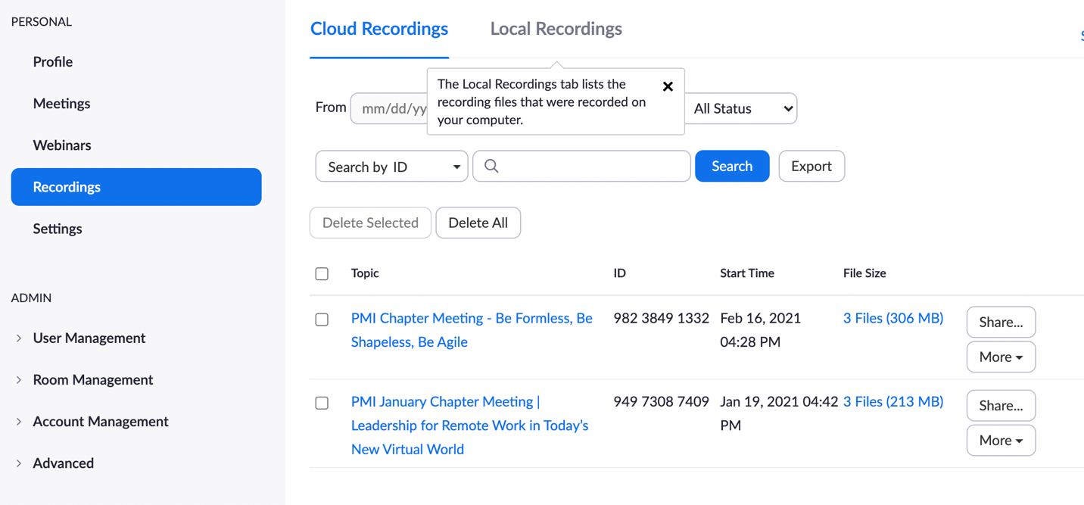
- Select the title of the session then you will see the 3 files, select the speaker view and select download.
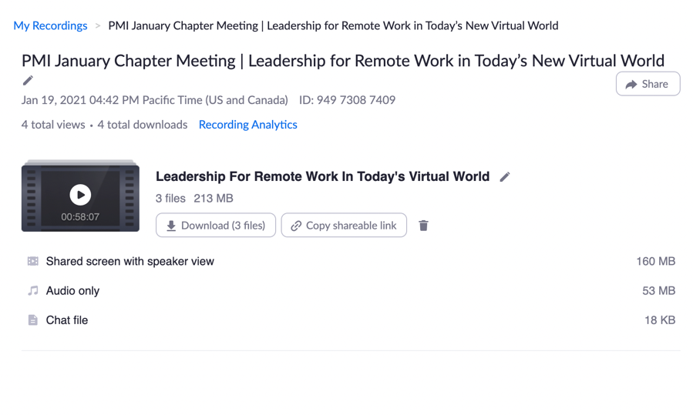
- To send the file if it is a large file size use wetransfer.com and upload the video to send out to the Web Admin and the presenter.
- Send a thank you to your presenter afterwards with the thank you message, let them know to be on the look out for the wetransfer.com mp4 file, and a week later you will send them the feedback from the participants.

A Week After The Event
- Log into your google forms presenter feedback survey form to collect the responses in a CSV file. Save a copy in your PMI google teams folder for future reference and discuss with your team in your post event debrief meeting.
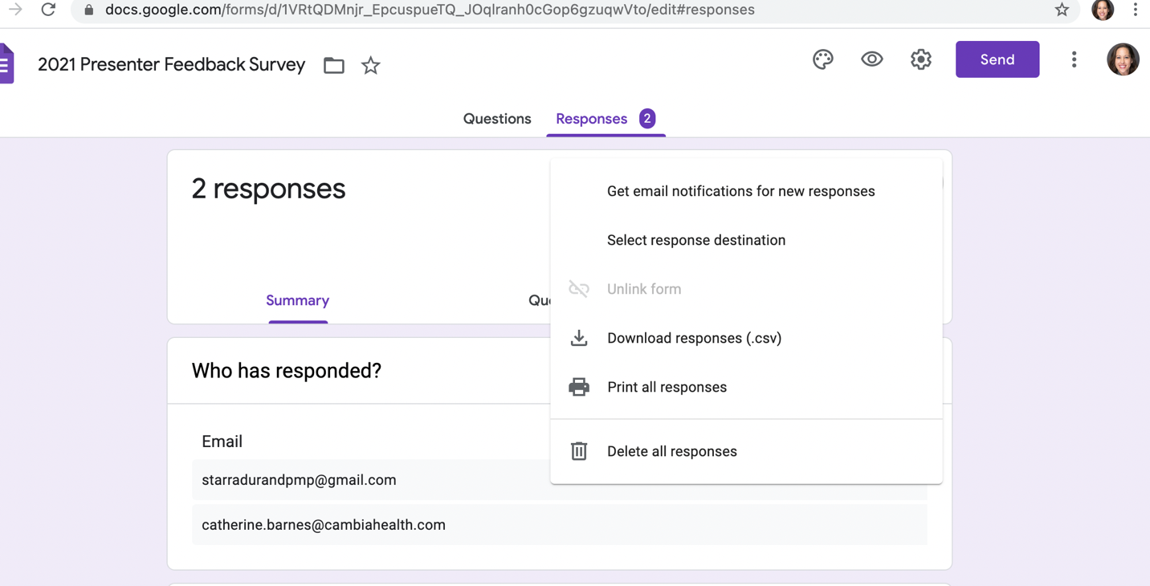
- Make a copy of the feedback csv file and then remove the emails and names of participants, keep the feedback and then send that to your presenter.
- Optional – pull the reg list and email the participants that didn’t attend the session (not on your attendance list) to let them know the on-demand session will be available for their review since they were unable to make it to the session.

Congrats, you have completed a virtual session!

